|  |  |  |  |  |  |
| --- | --- | --- | --- | --- | --- |
| CLK | Din | Q3 | Q2 | Q1 | Q0 |
| Initially | - | 0 | 0 | 0 | 0 |
| 1st falling  edge | 1 | 1 | 0 | 0 | 0 |
| 2nd falling  edge | 1 | 1 | 1 | 0 | 0 |
| 3rd falling  edge | 0 | 0 | 1 | 1 | 0 |
| 4th falling  edge | 1 | 1 | 0 | 1 | 1 |
| 5th falling  edge | - | - | 1 | 0 | 1 |
| 6th falling  edge | - | - | - | 1 | 0 |
| 7th falling  edge | - | - | - | - | 1 |

OUTPUT

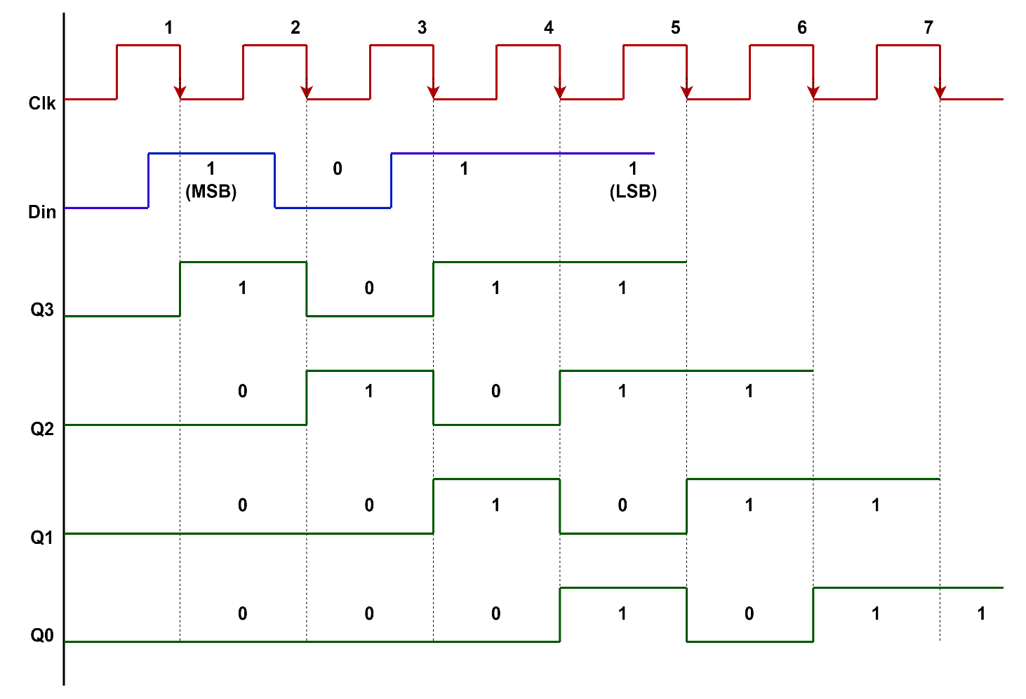

|  |  |  |  |  |  |
| --- | --- | --- | --- | --- | --- |
| CLK Pulse | Din | Q3 | Q2 | Q1 | Q0 |
| 0 | - | 0 | 0 | 0 | 0 |
| 1 | 1 | 1 | 0 | 0 | 0 |
| 2 | 1 | 1 | 1 | 0 | 0 |
| 3 | 0 | 0 | 1 | 1 | 0 |
| 4 | 1 | 1 | 0 | 1 | 1 |

OUTPUT

